Biostatistics Research Support: Annual Activity and Capacity Report
Reporting period: October 9, 2025 – October 9, 2026
Prepared by : Lomas Persad, Biostatistician 2, Department of Ophthalmology
Date prepared: October 9, 2026

1. Executive summary
30 unique projects with recorded activity during the past 12 months, including previously submitted projects that continued to receive support and pending projects. There were 17 new submissions during this reporting period. This count includes 4 IRIS projects where I only extracted data/clean the data.

2. Project volume and categories
Table 1. Projects with activity during the reporting period
Project status | Unique projects | Interpretation
Completed | 14 | Recorded as completed, with activity or completion during the period
Ongoing | 6 | Active projects requiring further support
Pending | 9 | Submitted projects not yet initiated, according to the register
On hold | 1 | Project temporarily paused
Total | 30 | Unique projects with recorded activity

Table 2. Cosmos/IRIS counts
Database | Unique projects
IRIS Registry | 18
COSMOS | 10
Both IRIS and COSMOS | 2
Total | 30

Table 3. New submissions during the past 12 months
Status | Projects submitted
Completed | 3
Ongoing | 4
On hold | 1
Pending | 9
Total new submissions | 17

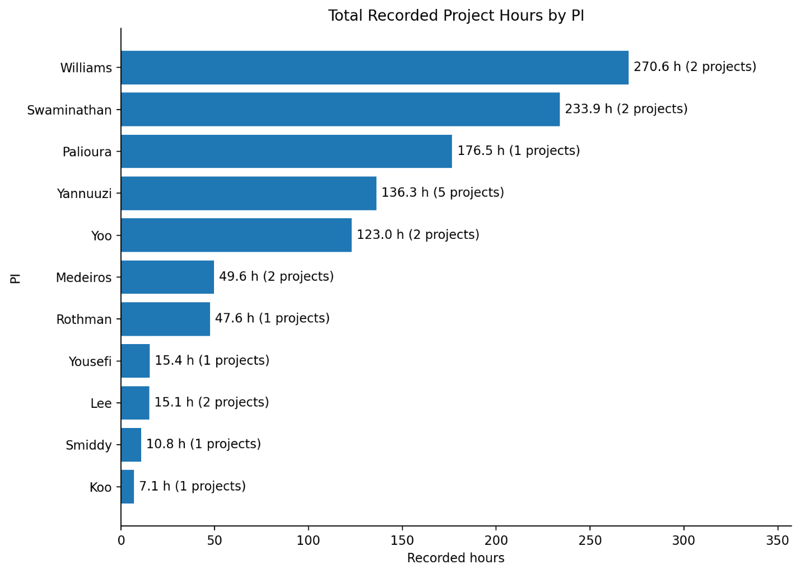

3. Research output and project support time/delay
Three confirmed publications in the 1 year period

Typical submission-to-start delay: 145 days ( median of 20 projects)
Typical support period: 30 days (median of 13 completed projects with recorded support time)
Average support period: 90 days (Mean of those 13 completed project)
Long-running projects: 150–260+ days (Observed among several completed projects)
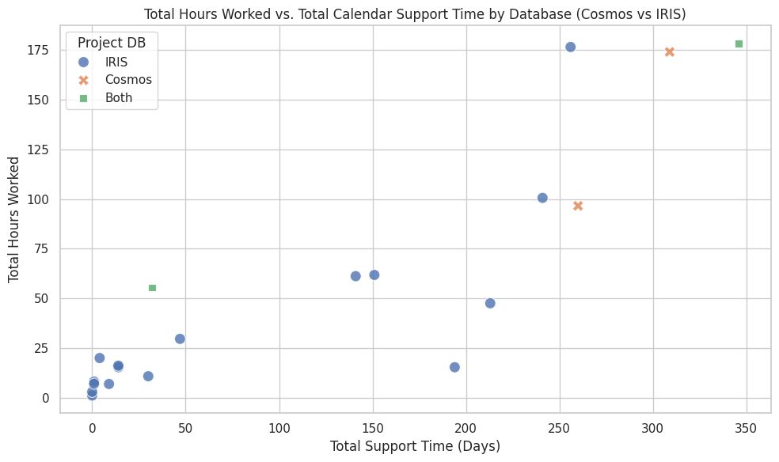
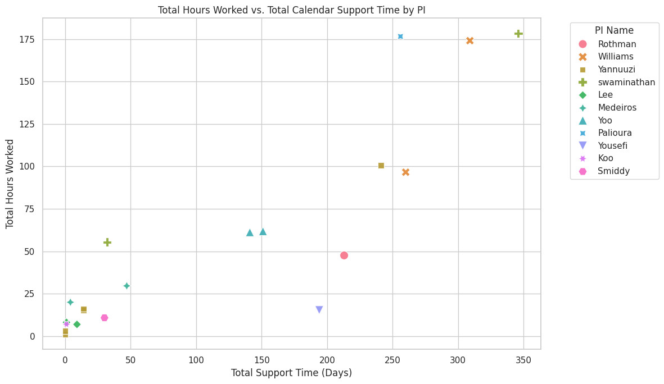

4. Resources and future needs
Research output tracking
There is currently no systematic way to capture the downstream output of supported work — abstracts, conference presentations, or peer-reviewed publications.
Workflow automation and infrastructure
Project management has been possible with AI assistance. It was, however, assembled incrementally rather than designed.
I plan to create two automations that would convert recurring manual effort:
- Intake-to-workspace pipeline. An agent reads an incoming project request, extracts the PI, title, database, aims, and required variables, and scaffolds the project workspace and register entry automatically.
- Ambiguity review. An agent reviews each new request against the data dictionary and prior project patterns, and returns a documented list of ambiguities, missing fields, and definitional conflicts before extraction coding begins.
The plan is to use Organization/department resources to host.

